Complementary Antonyms

🔹 What is Complementary Antonyms
# Source: Chatgpt (GPT-4-turbo) at [7/30/2025]
Complementary antonyms are word pairs in which the presence of one quality or state logically excludes the other. These antonyms form binary oppositions—no middle ground exists between them.

🧠 Definition:
# Source: Chatgpt (GPT-4-turbo) at [7/30/2025]
Complementary antonyms are opposites where only one of the pair can apply to a subject at a time—either-or situations.

📌 Key Characteristics:
# Source: Chatgpt (GPT-4-turbo) at [7/30/2025]
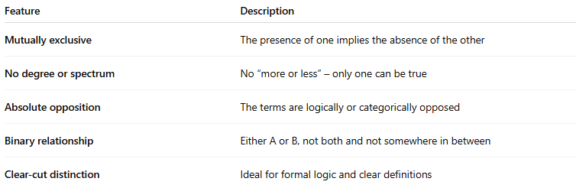
Feature | Description
Mutually exclusive | The presence of one implies the absence of the other
No degree or spectrum | No “more or less” – only one can be true
Absolute opposition | The terms are logically or categorically opposed
Binary relationship | Either A or B, not both and not somewhere in between
Clear-cut distinction | Ideal for formal logic and clear definitions

📚 Examples of Complementary Antonym Pairs:
# Source: Chatgpt (GPT-4-turbo) at [7/30/2025]
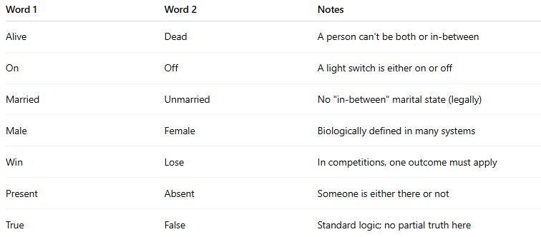
Word 1 | Word 2 | Notes
Alive | Dead | A person can't be both or in-between
On | Off | A light switch is either on or off
Married | Unmarried | No "in-between" marital state (legally)
Male | Female | Biologically defined in many systems
Win | Lose | In competitions, one outcome must apply
Present | Absent | Someone is either there or not
True | False | Standard logic; no partial truth here

✏️ In Context:
# Source: Chatgpt (GPT-4-turbo) at [7/30/2025]
- You can't be both dead and alive at the same time.
- The power is either on or off—check the switch.

🔁 Comparison:
# Source: Chatgpt (GPT-4-turbo) at [7/30/2025]
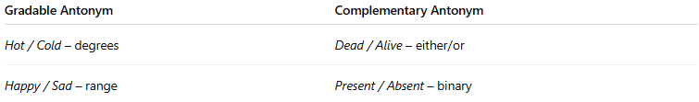
Gradable Antonym | Complementary Antonym
Hot / Cold – degrees | Dead / Alive – either/or
Happy / Sad – range | Present / Absent – binary

